Magnetism - 02
CLASS 10 - SCIENCE

 | Section A
1 | Which of the following property of a proton can change while it moves freely in a magnetic field?  a) momentum  b) speed  c) acceleration  d) mass | [1]
2 | A straight current carrying conductor is kept along the axis of circular loop carrying current. The force exerted by the straight conductor on the loop is  a) In the plane of the loop, towards the center  b) Zero  c) In the plane of the loop, away from the center  d) Perpendicular to the plane of the loop | [1]
3 | The elliptical coil makes an angle of 30° with a direction of a uniform magnetic field of 2$×$ 10 $​^{−2}$ T between the poles. The 20 turns of coil, measuring 20 cm by 100 cm and carries a current of 0.1 A, calculate the torque acting on the coil.  a) 1.6$×$ 10 $​^{−3}$ Nm  b) 1.2$×$ 10 $​^{−3}$ Nm  c) 2.5$×$ 10 $​^{−3}$ Nm  d) 1.4$×$ 10 $​^{−3}$ Nm | [1]
4 | Consider if a homocentric ring C has the radius of 8 cm which lies in a perpendicular plane, consists of 10 turn carries current of 18 A. Calculate the magnetic field to coil C at their center (Given:$μ_{0}$ is the permeability of free space = 4 $π×$ 10 $​^{−7}$ Tm A $​^{−1}$ )  a) 45$π×$ 10 $​^{−7}$ T mA $​^{−1}$  b) 45$π×$ 10 $​^{−3}$ T mA  c) 45$π×$ 10 $​^{−5}$ T mA $​^{−1}$  d) 45$π×$ 10 $​^{−2}$ Tm A $​^{−1}$ | [1]
5 | An electric fuse can prevent accidents arising from  a) An overload as well asshort circuit.  b) A short circuit but not due to overload.  c) An overload but not due to short circuit.  d) Neither an overload nor a short circuit. | [1]
6 | Strength of the magnetic field at a point in the space surrounding the magnet is measured by:  a) Thickness of the magnet  b) Length of the magnet  c) Resistance of it  d) Number of lines crossing a given point | [1]
7 | The graph showing the variation of the magnetic field strength (B) with distance (r) from a long current carrying conductor is  a) 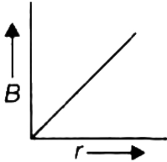  b) 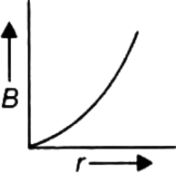  c) 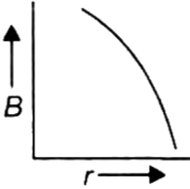  d) 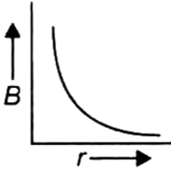 | [1]
8 | What will happen when a magnet is taken towards a circular coil?  a) Induced current will start flowing  b) No effect on the circular coil.  c) No effect of magnetic field.  d) No current will flow in the circuit. | [1]
9 | A cable carrying a steady flow of electrons if 20 A with 6 cm is placed in wind at the right angle to its axis. The magnetic field into the wind is given to be 0.47 T. Find the magnetic force on the cable.  a) 12.7$×$ 10 $​^{−2}$ N  b) 56.4$×$ 10 $​^{−2}$ N  c) 21.3$×$ 10 $​^{−2}$ N  d) 15.2$×$ 10 $​^{−2}$ N | [1]
10 | Transformer works on the principle of  a) Electro magnetic Induction  b) Electric field  c) Electricity  d) Magnetic field | [1]
11 | The magnetic field inside the solenoid is:  a) Non - uniform  b) Variable  c) Zero  d) Same at all points | [1]
12 | The magnetic field inside a long straight current carrying solenoid:  a) increases as we move towards its end.  b) is zero.  c) decreases as we move towards its end.  d) is same at all points. | [1]
13 | If it takes 520 turns to make a solenoid that is 40 cm long with a radius of 1.2 m that carries a current of 6 A, then determine the magnetic field inside the solenoid.  a) 7.2$×$ 10 $​^{−3}$ T  b) 10.2$×$ 10 $​^{−4}$ T  c) 8.4$×$ 10 $​^{−4}$ T  d) 9.8$×$ 10 $​^{−3}$ T | [1]
14 | Permanent magnets are made ofA. Steel B. Alnico C. Nipermag D. Tungsten  a) A and B  b) A, B and D  c) A, B and C  d) A and D | [1]
15 | What are the constituents of Alnico?  a) Al, Ni,Na  b) Al, Ni, Co  c) Mg, Mn, Al, Zn  d) Zn, Pb, Al, Ni | [1]
16 | By right hand thumb rule for current carrying wire the thumb point toward the  a) Direction of current  b) Direction of momentum  c) Direction of field lines  d) Direction of force | [1]
17 | Which rule determines the direction of flow of current in the conductor?  a) Fleming’s left hand rule  b) Fleming’s right hand rule  c) Maxwell’s right hand grip rule  d) Left hand thumb rule | [1]
18 | The strength of the magnetic field inside a long current carrying straight solenoid is  a) more at the ends than at the centre  b) found to increase from one end to the other  c) the minimum in the middle  d) same at all points | [1]
19 | A finite straight wire carries a current of 3 A, where it is a 2 m long and weighs around 240 g. If it is suspended in the mid - air by a uniform magnetic field then calculate the field B.  [  Acceleration due to gravity = 9.8 m/s$​^{2}$  ]  a) 0.42 T  b) 0.39 T  c) 0.61 T  d) 0.57 T | [1]
20 | At the time of short circuit, the current in the circuit  a) vary continuously  b) reduced considerably  c) does not change  d) increases heavily | [1]
21 | Two long parallel conductors I and II placed at right angles to a metre scale, at the 2 cm and 6 cm marks, as shown. They carry currents of 1 A and 3 A respectively in same direction. They will produce zero magnetic field at the 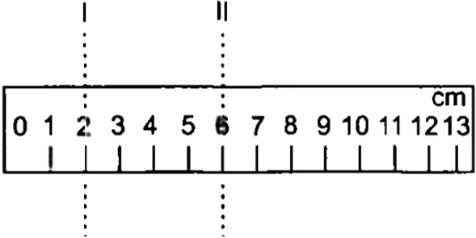  a) 6 cm mark  b) 3 cm mark  c) Zero mark  d) 10 cm mark | [1]
22 | A coil of many circular turn wrapped around a insulator forms a  a) Solenoid  b) Bar magnet  c) Circular magnet  d) U - shaped magnet | [1]
23 | A compass needle is kept far below, and parallel to a long straight current carrying wire. What is likely to happen to the compass needle?  a) Compass needle will defect towards right.  b) Deflects towards the west.  c) Compass needle is likely to remain unaffected.  d) Compares needle will deflect towards left. | [1]
24 | The magnetic field lines inside a solenoid are in the form of:  a) Parallel straight lines  b) Zig - zag lines  c) Curved line  d) Circular lines | [1]
25 | What are the factors affecting the strength of magnetic field at a point due to a straight conductor carrying current?  a) Current only  b) Distance of the point from the wire only  c) Current, length and distance of the wire  d) Length of the wire only | [1]
26 | Who first detected the presence of magnetic field in earth?  a) Maxwell  b) Gilbert  c) Michael faraday  d) H.C. Oersted | [1]
27 | Fleming’s Right - hand rule gives  a) both, direction and magnitude of the induced current  b) direction of the induced current  c) magnitude of the magnetic field  d) magnitude of the induced current | [1]
28 | What capacity of fuse wire is to be used for geyser?  a) 10 A  b) 15 A  c) 20 A  d) 5 A | [1]
29 | In our domestic electric supply we use following three colours of wire.  a) red, black, green  b) red, blue, green  c) black, green, yellow  d) red, black, blue | [1]
30 | What does the tangent at any point on magnetic field lines indicate?  a) direction of magnetic field  b) direction of the force  c) direction of current  d) direction of induced current | [1]
31 | A positron enters a uniform magnetic field at right angles to it as shown. The direction of force experienced by the positron will be: 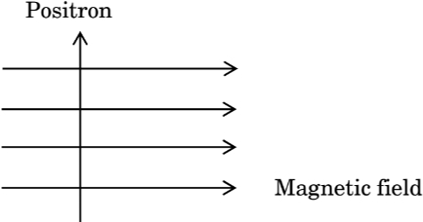  a) out of the page  b) into the page  c) to the right  d) to the left | [1]
32 | A toaster of 4 kW is running in an existing circuit 110 volt that has a stream ranking of 4 A. Find the stream of electrons drawn by the toaster.  a) 23.34 A  b) 36.36 A  c) 14.6 A  d) 9.06 A | [1]
33 | Which of the following property of a proton can change while it moves freely in a magnetic field? (There may be more than one correct answer.  - mass  - speed  - velocity  - momentum  a) Option (c) and (d)  b) Option (a)  c) Option (a) and (d)  d) Option (b) | [1]
34 | Which of the following is not an example of the right hand thumb rule?  a) A.C. generator  b) Solenoid  c) Cartesian coordinate system  d) D.C. motor | [1]
35 | H$​_{1}$ and H $​_{2}$ are heats produced by two copper wires have the same length and different diameters when they are connected series and parallel respectively. From the above, we infer what of the following?  a) H$​_{1}$ > H $​_{2}$  b) H$​_{1}$ < H $​_{2}$  c) H$​_{1}$ $≠$ H $​_{2}$  d) H$​_{1}$ = H $​_{2}$ | [1]
36 | Who said that current can cause magnetic field?  a) Maxwell  b) Fleming  c) Michael Faraday  d) Oersted | [1]
37 | The magnetic field at a point due to current carrying conductor is directly proportional to  - Current flowing through the conductor.  - Distance of the conductor.  - Resistance of the conductor.  a) A and C  b) A and B  c) Only B  d) Only A | [1]
38 | An electric current passes through a straight wire. If magnetic compasses are placed at the points X and Y as shown, then 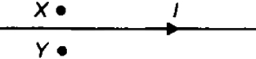  a) The needles will deflect in the same direction  b) Only one of the needles will deflect  c) The needles will not deflect  d) The needles will deflect in the opposite directions. | [1]
39 | What is the relation for magnetic field at the centre of a circular coil of radius r?  a) $\frac{2μoI}{r}$  b) $\frac{μoNI}{2r}$  c) $\frac{μoI}{r}$  d) $\frac{μoI}{4}$ | [1]
40 | In domestic electric circuits the wiring with 15 A current rating is for the electric devices which have  a) higher power ratings such as geyser.  b) non - metallic bodies and low power ratings.  c) metallic bodies and low power ratings.  d) lower power ratings such as fan. | [1]
41 | Which of the following describes the common domestic power supplied in India?  a) 110 v, 100 Hz  b) 220 v, 100 Hz  c) 110 v, 50 Hz  d) 220 v, 50 Hz | [1]
42 | The process of inducing a current in a coil of wire by placing it in a region of changing magnetic field is:  a) Electrical effect  b) Magnetic effect of current  c) Electromagnetic induction  d) Heating effect of current | [1]
43 | The most important safety device method used for protecting electrical appliances from short circuiting or overloading is  a) fuse  b) earthing  c) use of stabilizer  d) use of electric meter | [1]
44 | Calculate the magnetic field produced by the solenoid of length 50 cm with no. of turns in the coil 210 when the current passing through it 8 A. (Given permeability,$μ_{0}$ = 4 $π×$ 10 $​^{−7}$ Wb/Am)  a) 42.42$×$ 10 $​^{−7}$ T  b) 422.4$×$ 10 $​^{−7}$ T  c) 422.4$×$ 10 $​^{7}$ T  d) 4.22$×$ 10 $​^{−7}$ T | [1]
45 | A wire is placed perpendicular to the plane through point O. A constant current is flowing in the wire out of the plane. In the figure, the two points where magnetic field will be perpendicular to eachother is 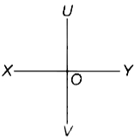  a) V and Y  b) U and V  c) None of these  d) X and Y | [1]
46 | The direction of force acting on a current carrying conductor placed in a magnetic fieldcan be obtained by:  a) Fleming’s right hand rule.  b) Ampere’s swimming rule.  c) Fleming’s left hand rule.  d) Clock face rule. | [1]
47 | Magnetic field lines determine  a) Only the direction of magnetic field.  b) Both the direction and the relative strength of magnetic field.  c) Only the relative strength of the magnetic field.  d) The shape of magnetic field. | [1]
48 | Two wires are placed in parallel; repulsion force and current in these two wires are f and I respectively. What will be a force if the current is doubled in each wire?  a) 4f  b) $\frac{f}{2}$  c) $\frac{2f}{4}$  d) 2f | [1]
49 | An electron beam is moving vertically upwards if it passes through a magnetic field which is directed from south to north in a horizontal plane then in which direction will the beam be deflected?  a) towards south  b) towards north  c) towards west  d) towards east | [1]
50 | When a coil carries current in an anti clockwise direction what pole does it create?  a) South pole  b) Zero pole  c) North pole  d) both South pole and North pole | [1]
51 | What is the current rating of domestic circuits used for appliances like an electric bulb, tube light, and fans?  a) 15 ampere  b) 2 ampere  c) 5 ampere  d) 10 ampere | [1]
52 | A positively - charged particle (alpha - particle) projected towards west is deflected towards north by a magnetic field. The direction of magnetic field is:  a) upward  b) towards east  c) towards south  d) downward | [1]
53 | The strength of an electromagnet after the limit cannot be increased by increasing the current through the solenoid. What is the reason behind this phenomenon?  a) Voltage through the solenoid gradually starts to decrease.  b) Electrons start to corrode the solenoid.  c) Resistance of the solenoid increases.  d) Current flowing through the solenoid is saturated. | [1]
54 | A wire is placed between the magnetic poles as shown in figure. In which direction does a force act on the wire? 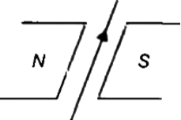  a) Vertically upward on the wire  b) From west to east  c) Vertically downward on the wire  d) From east to west | [1]
55 | Two current - conducting wires are hung on a plastic rod. A large current is passed through the two wires in the direction shown. Which of the following options is correct regarding this? 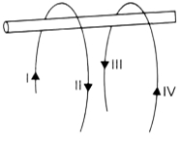  - I and III parts of wire repel each other  - II and IV parts of wire repel each other.  - I and IV parts of wire repel each other.  - II and III parts of wire repel each other.  a) Only (i) and (iv)  b) Only (i) and (iii)  c) Only (i) and (ii)  d) Only (iii) and (iv) | [1]
56 | In both Flem ing’s left - hand rules and Flem ing’s right - hand rule, the forefinger represents:  a) Motion  b) Induced current  c) Magnetic field  d) Current | [1]
57 | The fuse wire should have  a) Low resistance, High melting point  b) Low resistance, Low melting point  c) High resistance, High melting point  d) High resistance, Low melting point | [1]
58 | The magnetic field lines due to straight wire carrying a current are  a) Parabolic  b) Straight  c) Circular  d) Elliptical | [1]
59 | Which of the following correctly describes the magnetic field near a long straight wire?  a) The field consists of straight lines parallel to the wire  b) The field consists of concentric circles centred on the wire  c) The field consists of straight lines perpendicular to the wire  d) The field consists of radial lines originating from the wire | [1]
60 | The magnetic field inside a long straight solenoid - carrying current:  a) Is zero  b) Decrease as we move towards its end  c) Is the same at all points  d) Increase as we move towards it end | [1]
61 | A straight wire is placed between two poles of a magnet as shown in figure. If an alternating current is passing through the wire, then wire will 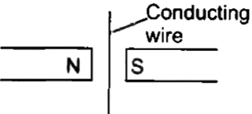  a) Move out of the page only  b) Move out and into the page  c) Move into the page only  d) Remain stationary | [1]
62 | Give names of two materials with which permanent magnets are made.  a) Carbon steel, chromium steel  b) Aluminium, cobalt  c) Alnico, Neodymium  d) Tungsten, steel | [1]
63 | The magnetic field strength of a solenoid can be increased by inserting:  a) A wooden piece into it  b) An iron piece into it  c) A glass piece into it  d) Paper roll into it | [1]
 | Section B
64 | State True or False:  - The space around a magnet in which the force of attraction and repulsion caused by the magnet can be detected is called the magnetic field.  - The magnetic field produced by the solenoid is similar to the magnetic field produced by the bar magnet.  - The direction of the magnetic field at any point is obtained by drawing a tangent to the field line at that point.  - The field lines inside the solenoid are in the form of parallel straight lines.  - An electric fuse is an important component of all domestic circuits.  - A magnetic field line is a closed and continuous curve.  - A compass needle is a small bar magnet whose ends of the compass needle point approximately towards north and south directions.  - The field at the centre of a long circular coil carrying current will be parallel straight lines.  - A wire with green insulation is usually the live wire of electric supply.  - A fuse is a safety device having a short length of a thin, tin - plated copper wire, andlow melting point. | [10]

